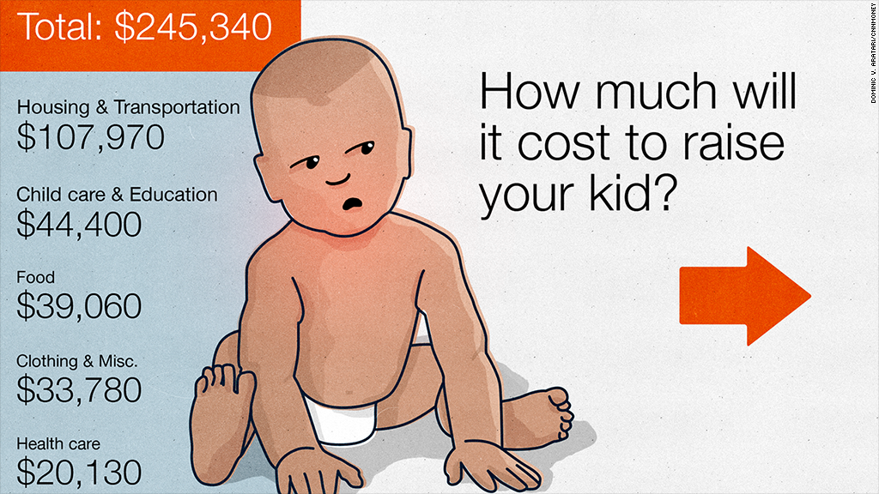

<http://money.cnn.com/2014/08/18/pf/child-cost/>